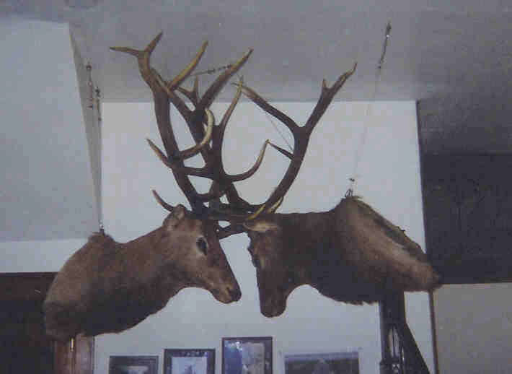
Who
Became the Leader of the Herd?
To our knowledge, there isn’t such an unusual trophy display in the United
The man who discovered them was Shirley Avery. In his own words, he told the following Story:
“We were out in the mountains on Castle Rock Gulch, north of Salida, CO. in the Basam Park area. At the summit of the gulch, we saw trees torn up and a wide path going down to the bottom. Trees were demolished, earth appeared as though a plow had gone through, and as we approached the lower part of the gulch, we sighted the two elk lying in a beaver pond. We waded into the pond and touched the carcasses and both were still warm, and we assumed that they had died shortly before we found them. They had cut the path though the aspens and underbrush in their battle downward.
We immediately c;iombed up the path and headed for Buena Vista to inform the game warden of our discovery. Clay Jordan was game warden at the time; we returned to the scene and with some assistance and drug the two elk out of the water upon the bank. The next morning we returned and severed the heads from both animals, and brought them to the locker plant in Salida.
In the meantime I went to the Elks Lodge and told them the story and asked them if they would like to have them for their trophy room. The answer was affirmative. At this point the Wildlife and Game Division of the State of Colorado wanted the pair for exhibition in their own headquarters. After much bickering, the division finally consented to give them to the Lodge.
We took the trophies to a taxidermist in Poncha Springs who mounted them and they were suspended in our Lodge Home.”
Brother Avery was a member for our lodge for many years until his retirement This unusual trophy was discovered in September of 1965 and we again thank Brother Shirley Avery for his thoughtfulness and generosity.
In checking with knowledgeable sportsmen and history of wild life, we learn that a bull elk is leader until the time comes when another younger elk decides to do battle for that position. We are told that this holds true among all big game animals. These facts prompt the heading of this story. Who?

